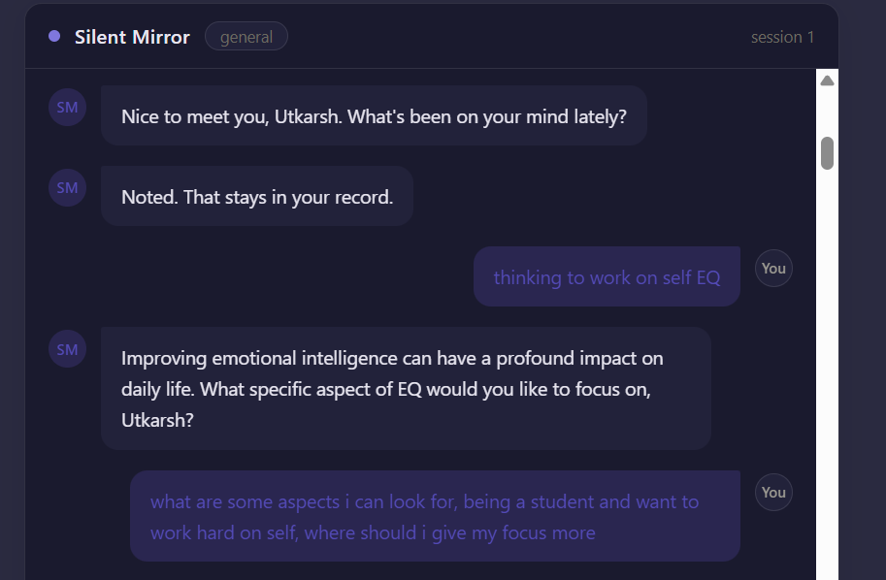
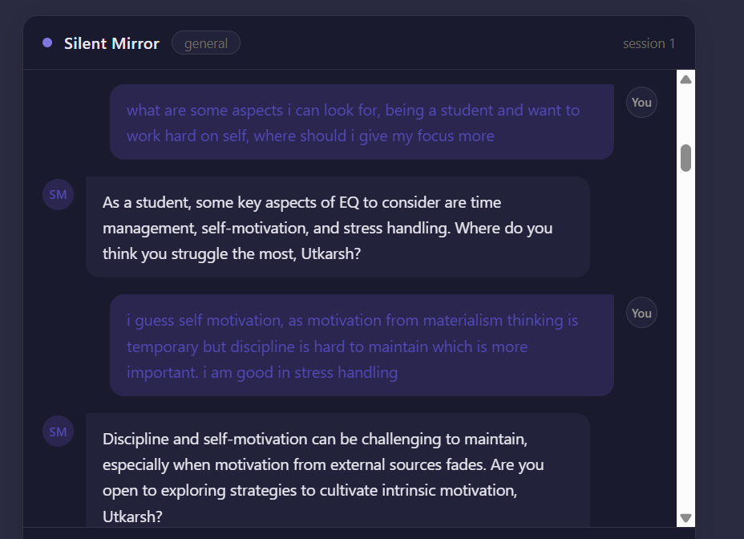
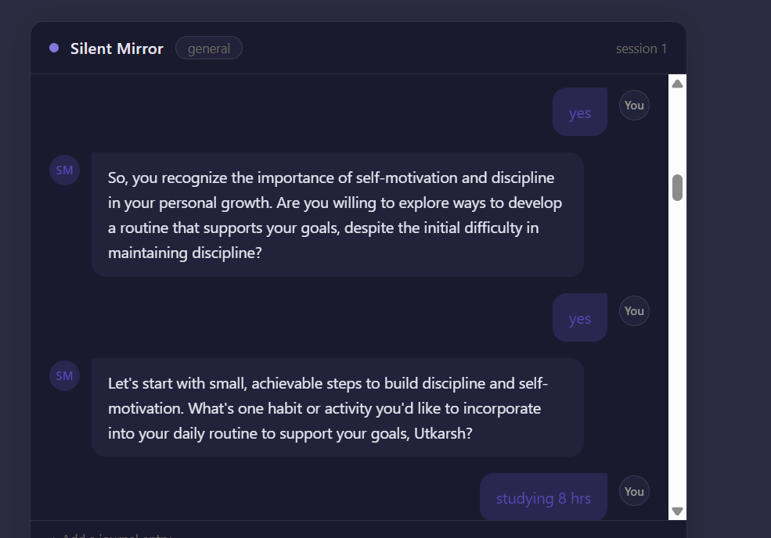
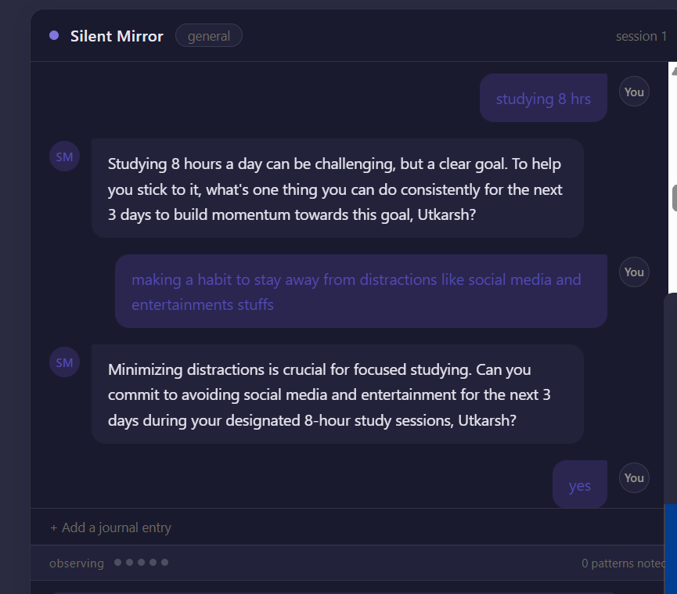
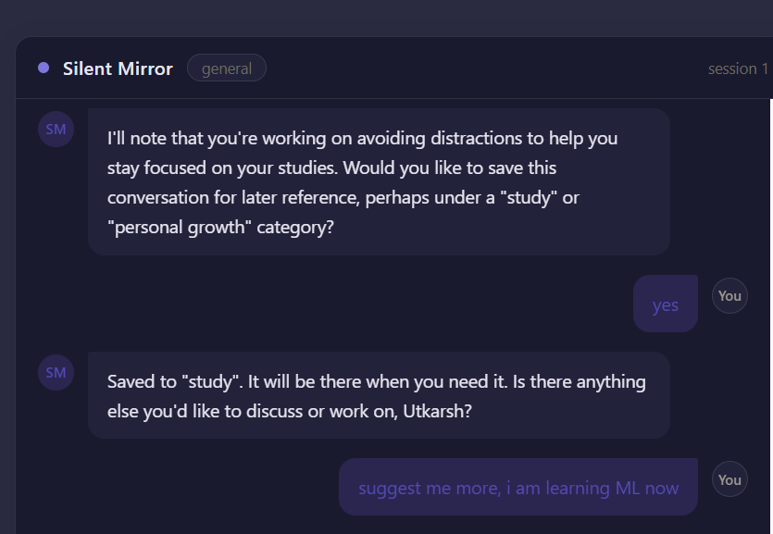
You have no ground truth. Nobody can tell you objectively "yes, this user really does withdraw under stress" — there's no external label to check your system against, unlike a typical ML problem where you'd have a labeled test set and could just measure accuracy. So: how would you actually evaluate whether Silent Mirror's reflections are any good — not "does the code run without errors," but "are the insights actually correct, useful, and appropriately calibrated"? Walk me through what you'd measure, and be honest about what you can't measure no matter how clever your evaluation gets.
Solution- 1. "You have no ground truth."
This is the key phrase.
Ground truth means the objectively correct answer against which you compare your model.
Examples where ground truth exists:
- Image classification: the image actually contains a cat.
- Spam detection: the email was manually labeled as spam.
- Disease prediction: medical diagnosis confirmed by doctors.
Your model can simply ask:
"Was I right?"
Silent Mirror is different.
If Silent Mirror says:
"You seem to withdraw from people when you're stressed."
Who can prove that?
There is no database saying:
✔ Correct.
or
✘ Incorrect.
The user's own perception may even change over time.
So the interviewer is asking:
How do you evaluate an AI when there is no objectively correct answer?

2. "Nobody can tell you objectively..."
This expands on the first idea.
Imagine two psychologists observe the same person.
Psychologist A:
"The user avoids conflict."
Psychologist B:
"The user protects themselves emotionally."
Psychologist C:
"The user simply prefers solitude."
All three might be reasonable.
None is perfectly "correct."
Unlike mathematics:
2 + 2 = 4
Human behavior isn't like that.

3. "Unlike a typical ML problem..."
They're contrasting Silent Mirror with normal machine learning.
Typical ML looks like:
Training data

Image
↓

True label = Dog

↓

Model predicts = Dog

↓

Correct
Evaluation is straightforward.
Silent Mirror instead looks like:
Conversation

↓

Reflection:
"You often doubt yourself before making decisions."

↓

???
There is no label.
No answer key.

4. "How would you actually evaluate..."
Notice they don't ask:
"How would you build it?"
They ask:
How would you know whether it is good?
These are completely different questions.
Many engineers focus on building.
Senior AI engineers think equally about evaluation.

5. "Not 'does the code run without errors'..."
This rules out technical testing.
The interviewer isn't interested in:
- API works
- Database saves chats
- No crashes
- Fast response
- UI looks good
Those are software quality.
They're asking about AI quality.

6. "...but 'are the insights actually correct...'"
This introduces the first evaluation dimension.
Suppose Silent Mirror says:
"You seem to avoid difficult conversations."
The interviewer asks:
Is that actually true?
But remember—
There is no objective answer.
So now you're forced to think differently.

7. "...useful..."
Even if an insight isn't perfectly true...
...it may still help.
Example:
Reflection:
"Maybe you're being harder on yourself than you realize."
Maybe that's not objectively provable.
But if it helps the user reflect...
...perhaps it's valuable.
The interviewer is separating:
- Correctness
- Helpfulness
Those are different concepts.

8. "...appropriately calibrated?"
Calibration is another concept entirely.
Imagine two statements.
Reflection A:
"You definitely have abandonment issues."
Reflection B:
"Based on this conversation, there's some evidence that you may become anxious when relationships feel uncertain."
Same topic.
Different certainty.
The interviewer wants to know:
Does your AI express confidence appropriately?
Not too certain.
Not too vague.

9. "Walk me through what you'd measure."
Notice the wording.
Not:
"Give me one metric."
Instead:
"Explain your evaluation strategy."
They're looking for your thinking process.

10. "Be honest about what you can't measure..."
This is perhaps the most important sentence.
Many candidates try to sound impressive.
The interviewer instead wants intellectual honesty.
They're asking:
What are the fundamental limits of evaluation?
Some things simply cannot be measured perfectly.
Recognizing those limits is often a sign of mature engineering judgment.

What the interviewer is really testing
Behind this one question are several deeper ideas:
- Do you understand the difference between software evaluation and AI evaluation?
- Do you understand what ground truth means?
- Can you reason about systems where there is no single correct answer?
- Do you separate accuracy, usefulness, and confidence instead of treating them as the same thing?
- Can you acknowledge the limits of what can and cannot be measured, rather than claiming certainty where none exists?
In other words, this isn't just a question about Silent Mirror. It's a question about your ability to think like someone building AI for complex human-centered problems, where evaluation is often much harder than model development itself.

